Simple program to create a moving car in graphics

#include<graphics.h>

#include<conio.h>

#include<dos.h>

void main()

{

int gdriver=DETECT,gmode,i=0,j=0;

initgraph(&gdriver,&gmode,”c:\turboc3\bgi”);

for(i;i<420;++i)

{

line(0,245,650,245);

line(0+i,200,210+i,200);

line(50+i,200,70+i,170);

line(70+i,170,140+i,170);

line(140+i,170,160+i,200);

line(85+i,170,85+i,200);

line(125+i,170,125+i,200);

line(0+i,200,0+i,230);

line(210+i,200,210+i,230);

line(0+i,230,50+i,230);

circle(65+i,230,15);

line(80+i,230,130+i,230);

circle(145+i,230,15);

line(210+i,230,160+i,230);

pieslice(65+i,230,359-j,360-j,15);

pieslice(65+i,230,179-j,180-j,15);

pieslice(65+i,230,89-j,90-j,15);

pieslice(65+i,230,269-j,270-j,15);

pieslice(145+i,230,359-j,360-j,15);

pieslice(145+i,230,179-j,180-j,15);

pieslice(145+i,230,89-j,90-j,15);

pieslice(145+i,230,269-j,270-j,15);

if(j==179)

j=0;

++j;

delay(30);

cleardevice();

}

closegraph();

}

Program for Midpoint Circle Algorithm in C++

|  |  |
| --- | --- |
| 1  2  3  4  5  6  7  8  9  10  11  12  13  14  15  16  17  18  19  20  21  22  23  24  25  26  27  28  29  30  31  32  33  34  35  36  37  38  39  40  41  42  43  44  45  46  47  48 | #include<iostream.h>  #include<graphics.h>  void drawcircle(int x0, int y0, int radius)  {  int x = radius;  int y = 0;  int err = 0;  while (x >= y)  {  putpixel(x0 + x, y0 + y, 7);  putpixel(x0 + y, y0 + x, 7);  putpixel(x0 - y, y0 + x, 7);  putpixel(x0 - x, y0 + y, 7);  putpixel(x0 - x, y0 - y, 7);  putpixel(x0 - y, y0 - x, 7);  putpixel(x0 + y, y0 - x, 7);  putpixel(x0 + x, y0 - y, 7);  if (err <= 0)  {  y += 1;  err += 2*y + 1;  }  if (err > 0)  {  x -= 1;  err -= 2*x + 1;  }  }  }  int main()  {  int gdriver=DETECT, gmode, error, x, y, r;  initgraph(&gdriver, &gmode, "c:\\turboc3\\bgi");  cout<<"Enter radius of circle: ";  cin>>r;  cout<<"Enter co-ordinates of center(x and y): ";  cin>>x>>y;  drawcircle(x, y, r);  return 0;  } |

**Output**

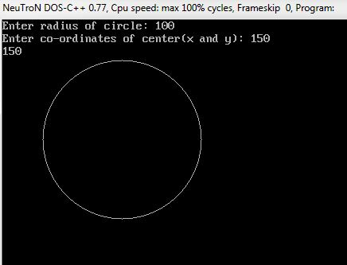

Simple graphics program in c ++ :

#include  
#include  
#include  
void main()  
{  
int gd,gm,i;  
gd=0;  
gm=0;  
initgraph(&gd,&gm,”your bgi path “);  
setcolor(GREEN);  
setlinestyle(0,1,1);  
rectangle(100,100,200,200);  
setlinestyle(2,1,3);  
rectangle(200,200,400,400);  
getch();  
closegraph();  
}

**Example links : http://www.dailyfreecode.com/tutorial_simple_cpp-16/computer-graphics-215.aspx**